Bob Gerner’s Richmond Annex Life
A longtime Annex resident remembers a free-range childhood—and how the neighborhood market of his youth became his life’s work.
By David Evans
Bob Gerner is a born storyteller. If it happened in the past 75 years of the Richmond Annex’s 100-year history, Bob can recall it in detail – and tell you an interesting story about it. For Bob Gerner, the Richmond Annex is not simply where he grew up -- it is a map of family stories, childhood adventures and neighborhood businesses that shaped his life. His parents bought their Huntington Avenue home in 1931, shortly after marrying. Gerner was born in 1946, the youngest of four children, part of the postwar baby boom that filled the neighborhood with playmates.
People in the East Bay may know Bob Gerner as the guy who co-founded Berkeley Natural Grocery in 1982 and the El Cerrito Natural Grocery in 1988, opened The El Cerrito Prepared Food Annex (“The Annex”) in 2014, or even as the guy who served the first tofu burger in the USA.
His family’s roots stretched beyond the Annex. Gerner’s father, John, learned the butcher’s trade from his own father, a German immigrant who had run a San Francisco butcher shop, worked a Mojave Desert gold mine and later operated a meat-packing business near Gilman Street and San Pablo Avenue. John worked as a butcher and at the Kaiser shipyards, where family lore says he also dealt cards during lunch. John Gerner had a knack for dealing cards – which he did at three legendary establishments on San Pablo Avenue in the early 1940s -- the It Club, the Pastime Club, and the Bank Club.
“There were so many kids to play with, it was unbelievable.”
— Bob Gerner

A Neighborhood Full of Kids
Gerner remembers Huntington Avenue in Richmond Annex as a working-class street of butchers, stevedores, truck drivers and other tradespeople. Children moved freely among houses and blocks. His lifelong friend Mark Sedlacek lived across the street; the Buffum family became another second home. Friday nights meant Canasta, Ten High, cribbage or pinochle in the basement—before the onset of television.
The children of the neighborhood organized their own world. Blocks challenged one another to baseball, basketball and football. Water-balloon wars began with wagons piled high with ammunition. Gerner attended Alvarado School and served as a student traffic lieutenant, helping squads of children stop cars with signs and whistles so classmates could cross Carlson Boulevard.
Entertainment was close and inexpensive. Gerner and his friends walked or rode bicycles to the Cerrito, Albany and Oaks theaters. His traffic-patrol service earned him free admission to the Cerrito, while the Albany cost a nickel. Clothes, by contrast, were precious: one or two pairs of school pants had to last the year, making a tumble on Alvarado’s rough hillside a serious household event.
Gerner recalls growing up next to the Richmond Annex Firehouse, now the Richmond Annex Senior Center at 5801 Huntington Avenue. “It was a real treat to go to the firehouse and get a soda pop for a nickel – a Nehi or a Hires root beer.”

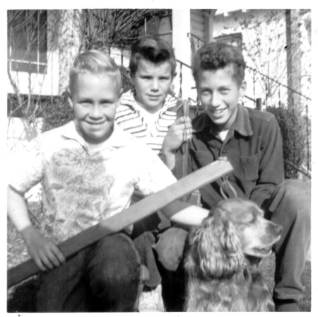

Bob Gerner (right) and friends about to embark upon neighborhood shenanigans

Rafts on the Bay
.Gerner’s favorite adventure took place at the edge of the Bay. He and friends gathered driftwood, brought hammers and nails, and built rafts in the marsh. Their timing depended on the tide: too high and the raft would not fit beneath the railroad bridge; too low and it could not move through the channels. A sturdy raft might last six months, hidden in the grass between outings.
“Our favorite thing to do, bar none, was to go out into the bay and build rafts.”
— Bob Gerner
Gerner recalls rafting trips on the Bay with delight, despite the smelly and possibly toxic environment of the Bay and Richmond marshes in the 1950s. Parents forbade the trips, but Bob says that he and his friends were undeterred. “You saw your mom at breakfast,” Gerner recalled, “and then you came home for dinner. You’d take off your shoes, and they might smell like sewage, and you might get in trouble.”
Another site of youthful mischief for Gerner was the old Castro Adobe, where El Cerrito Plaza now stands. “I remember the old, abandoned Adobe, we used to play there. I was so upset when it burned down (in 1956).” Closer to home, a vacant lot that later became Huntington Park offered equal excitement. Gerner and his youthful compadres dug six-foot holes, roofed them with boards and turned them into forts. Once the park was built, baseball replaced fort-building. Gerner remembers a scary moment when a ball he hit flew across the street, breaking a neighbor’s window. The neighbor’s response was memorable: “The ball landed on my dining room table. Good hit!”

El Nido Market: More Than a Store
Neighborhood identity was tied to shopping. Families shopped either at Safeway (where the Credence apartment building now stands on San Pablo Avenue), Louis Stores (where the Soccer Post now stands), or the El Nido Market, and Gerner’s family was loyal to the El Nido Market. Opened by Joe Fara in 1927, the market expanded several times and employed people for decades. Staff became so familiar that a worker hired in the 1950s could still be called “the new guy” ten years later.
That familiarity mattered. The market was a place where children accompanied their parents, neighbors exchanged news and generations knew the butcher behind the counter. Even after the Fara family sold the business, and the El Nido went into a long, slow decline, Gerner’s mother continued to shop there. She never drove a car – like many people in the Richmond Annex, she walked or took a bus everywhere.
“You were defined in the neighborhood by where you shopped.”
— Bob Gerner

A Conversion to Natural Foods
Gerner graduated from El Cerrito High and left Richmond for UC Davis, having no thought of entering the food business. But he found himself getting involved in and then managing the Student Owned Coffee House at UC Davis. A visit to Sacramento Real Foods changed his direction almost overnight. He became convinced that organic food and fewer chemicals deserved wider support. The idea also echoed his family kitchen: his father cooked from scratch, favored pumpernickel and whole grains, and teased his children for eating white bread.
In 1971 Gerner helped start Westbrae Natural Foods on Gilman Street in Berkeley. He later developed Gilman Street Gourmet, adding a bakery and a delicatessen meant to make natural foods approachable to people beyond the counterculture. The work eventually became Berkeley Natural Grocery, and Gerner’s commitment to organic and whole foods grew into a career.
Then the old El Nido opportunity appeared. By the late 1980s, the once-busy store had declined. “The (manager) had just trashed it. Stopped the butcher shop, and he didn't have fruit, and he sold basically cigarettes, beer, and booze,” recalled Gerner. Gerner acquired the lease at the end of 1987 and undertook an extensive remodel.
The renovated store opened as the El Cerrito Natural Grocery in December 1988. Nearly everything was replaced except the meat counter. “Armond Macchi was the butcher at the El Nido Market. In 1953 he bought a top-of-the-line meat counter – the very best.” In a gesture of continuity, Gerner invited the former butcher’s son to run the meat counter, “Armond’s Meats”.

Homecoming on San Pablo Avenue
Gerner says the acquisition was not part of a grand expansion plan. It was personal. As a young Berkeley grocer, he had already wished for a store like El Nido—with parking and a central neighborhood location. Years later, the place where his family had shopped became the place where he could bring organic food back to his own community. Gerner has always wanted the market, a continuation of his local boyhood market that first opened in 1927, to have a secure future. In 2002, Gerner took a step unusual for a profit-driven grocery store – the business became employee-owned.
In 2013, Gerner and his colleagues smelled an opportunity at a property also tied to his childhood memories – the one immediately north of El Cerrito Natural Grocery, at the corner of San Pablo and Panama. As a child, Gerner used to enjoy going to the soda fountain at Amerio Drugs with his family. After the demise of Amerio Drugs, the property became a Sherwin-Williams paint store. Gerner had his eye on the store. He made the owner a “very decent” offer to rent the property and was turned down. After Sherwin-Williams vacated the property, the owner had a plan to divide the property up into four sections, even going so far as to present his plan to a meeting of the Richmond Annex Neighborhood Council (RANC). The community was thoroughly unimpressed – “people stood up and said they wanted it to match El Cerrito Natural Grocery,” Gerner recalled. Soon after, Gerner acquired the lease – and after a thorough renovation, “The Annex” opened in 2014. Gerner knows the 100-year history of the Richmond Annex – the name “The Annex” is an homage to a small grocery that once thrived a stone’s throw away on San Pablo Avenue.
If the El Cerrito Natural Grocery and The Annex feel like a cherished part of our community, it is likely because Bob Gerner has always had a community-minded approach. His deep history in the Richmond Annex allowed him to transform his childhood market into a thriving part of our community.

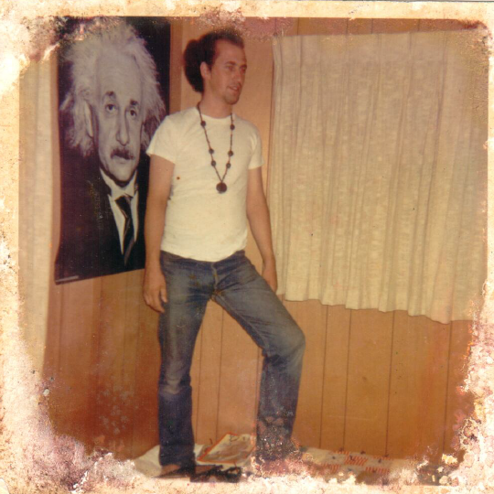

Bob Gerner in Davis, ca. 1970, possibly contemplating granola.

